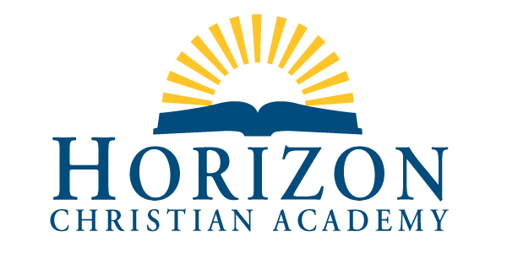

2020 Summer Service Opportunities and Ideas

As we able to begin to venture out, there are summer activities that can count as service at HCA. Please use your best judgement and be safe. Also note that there is a special list at the end that applies to this summer only.

General service activities:

Volunteering at Vacation Bible School

Keeping the nursery at your church

Volunteering to help or lead a kids program at your church

Serving as a summer camp volunteer (Church, Scouts, YMCA, etc.)

Doing yard work for neighbors that need help

Volunteer babysitting

Volunteering to sit or spend time with a senior citizen

Helping toward the Fourth of July parade float for a nonprofit group

Cleaning / storing sports equipment for HCA teams

Helping around the campus after school is out or in preparation to start school in August

Volunteering to help at a fun run

Cleaning up a road, trail or public shore

Local resources and contact links that might be of interest to you:

Deliver Meals to Homebound - Forsyth Co. GA
GA Mountains RSVP (Retired & Senior Volunteer Program)
595 Dahlonega Road Cumming, GA 30040

WordPress Project – United Way of Forsyth
240 Elm Street Cumming, GA 30040
https://www.volunteermatch.org/search/org912531.jsp

Client Choice Pantry - Meals by Grace
432-A Canton Road Cumming, GA 30040

OR

Meals by Grace food support volunteers serve Forsyth County families every Sunday at Midway United Methodist Church from 1 pm to about 3. 5025 Atlanta Hwy. Midway Church (Gym) , Alpharetta, GA
https://mealsbygrace.org/

Swim for MS !
Swim in your own location on your own schedule ---
http://support.mymsaa.org/site/TR/Events/General?fr_id=1480&pg=entry

Bags of Love
https://marcus-sharon-gunter-foundation.org/

This activity was suspended in the spring due to the Corona Virus. Please consult the website for their current status.

Special Covid 19 Activities:

Learning how to cook. Prepare, cook, serve and clean up after a meal for your family.

Learning how to change the oil in a car, change a flat tire or perform other basic maintenance. This can be a virtual experience, online study or a hands-on lesson.

Learning who to call, how to contact them, and information to convey in case of a roadside emergency. (Mom and Dad don’t count!) Hopefully you will never need this skill, but it is important to know.

Learning how to balance checkbooks and accounts, do taxes, make a budget or complete other financial functions. Although everyone needs to know how to manage their personal finances, the complexity of this will vary according to age, interest and maturity level.
Learning basic first aid and emergency preparedness. This can be virtual, online or hands on.
Learning how to ask for and give driving directions from important places in your community to home and the reverse. With so much dependence on navigation apps, many students have no idea how to ask for or understand directions or read maps. Students should learn about these alternatives to GPS and practice with parents.
Learning how to sort clothes and do laundry. Students should have to actually do the laundry for the family at least once to complete this.
Taking and completing a safety course for babysitting. Again, this can be virtual, online or hands on.
Learning proper etiquette and form for business letters and emails

Please note: Time spent in these activities will vary greatly. It is therefore important to track the time spend and report it at your convenience on the service form attached to this same email.

As always, if you have any questions or concerns, please contact me at melanie.godwin@hcaga.org.

Melanie Godwin
Dean of Student Services
Horizon Christian Academy

